Long-Term Effects of Exercise
GCSE PE – Revision Bo klet
Ap lied Anatomy and Physiology
Physical Factors Affecting Performance
Student Book





What the Specification Says:

Learners must understand the effects of long-term exercise on the muscular system, cardiovascular and respiratory systems.

The Muscular System
The muscular system responds to long-term exercise in several stages: the hypertrophy of muscles leads to an increase in muscular strength and endurance.

Can you state the effect of each stage of the response?

Response | Effect
hypertrophy of muscles
increase in muscular strength
increase in muscular endurance

Choose a specific athlete and explain how these effects are of benefit to them.

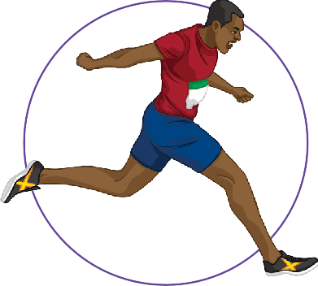

The Skeletal System
Long-term exercise can also benefit the skeletal system by increasing bone density through an increase in calcium.

Give an example of an exercise that will lead to an increase in bone density.

The Respiratory System
The respiratory system responds to long-term exercise in several stages: an increase in the strength of the respiratory muscles leads to an increase in tidal volume, minute respiration and vital capacity.

Definitions

Breathing rates can be quantified in several ways:
tidal volume – The volume of air that is inhaled and exhaled per breath.
minute ventilation – The volume of air that is inhaled and exhaled in one minute. vital capacity – The volume of air that can be exhaled after breathing in.

Can you state the effect of each stage of the response?

Response | Effect
Increased strength of respiratory muscles
increased tidal volume, minute ventilation and vital capacity

Choose a specific athlete and explain how these effects are of benefit to them.



Cardiovascular System
The cardiovascular system responds to long-term exercise in several stages: an increase in the size and strength of the heart leads to an increased stroke volume and cardiac output, as well as a lower resting heart rate. In turn, this causes more capillaries to form in the muscles.

Definitions

The effectiveness of the heart can be quantified in several ways:
heart rate – Number of contractions per minute.
stroke volume – Volume of blood that is pumped out of the heart during one contraction. cardiac output – Volume of blood that is pumped out of the heart each minute.

Response | Effect
hypertrophy of the heart
lower resting heart rate
increased resting stroke volume and cardiac output
more capillaries in muscles
Choose a specific athlete and explain how these effects are of benefit to them.

True or False?

- Increased heart rate is a short-term response to exercise.

- A short-term response of exercise is a lower resting heart rate.

- More capillaries lead to an increase in gaseous exchange in the alveoli.

- A trained athlete generally has a lower resting heart rate than an untrained person.

- Increased bone density is a long-term effect of exercise on the cardiovascular system.

Extension Task:

Formulate another three ‘true or false’ questions on the topic of long-term effects of exercise. Try them on a friend!

Look at the data below and use it to explain which performer is the trained athlete. Performer A:
Resting heart rate = 74bpm
Exercising heart rate = 145bpm
Time to recover from exercising heart rate to resting heart = 16 minutes

Performer B:
Resting heart rate = 52bpm Exercising heart rate = 105bpm
Time to recover from exercising heart rate to resting heart = 7 minutes

